Customer Analytics for Improving Homelessness Outreach, Housing Access, and Service Conversion in Cumberland County
Group 1: Mercy Harris, Zariana Mobley and Braeden Baker
Fayetteville State University
School of Business
Advanced Analytics- BIDA 670
Professor Majed Al- Ghandour
April 30, 2026

Contents
Executive Summary 4
Motivation 4
Objectives 4
Problem Definition 5
Literature Review 6
Approach / Methodology 9
Data Collection 11
Data Analysis and Key Findings 13
Qualitative Portion 15
Forecast and Volatility Analysis 15
Implementation and Recommendations 17
Improving outreach and engagement 17
Increase Conversion Through Capacity Alignment 17
Leveraging Forecasting for Resource Planning 18
Enhancing Data Collection and Integration 18
Continuous Monitoring and KPI Development 18
Project Evaluation 18
Project Outcomes 18
Contributions and Learning 19
Team Performance 19
Conclusion 20
Appendix 22
Appendix A: North Carolina Data and Analysis 22
Figure A1: North Carolina Homeless Population Trends (2007-2024) 22
Figure A2: North Carolina Overall Homeless Forecast with Volatility Bands (2025-2027) 23
Table A2: North Carolina Forecast Volatility Bands by Category (2025-2027) 23
Appendix B: Cumberland County Data and Analysis 23
Figure B1: Cumberland County Homeless Population Trends (2007-2024) 23
Table B1: Cumberland County Year-over-Year Percentage Changes (2007-2004) 24
Figure B2: Cumberland County Overall Homeless Forecast with Volatility Bands (2025-2027) 24
Table B2: Cumberland County Forecast Volatility Bands by Category (2025-2027) 24
References 25

Executive Summary
​This project applies customer analytics and marketing strategy concepts to improve homelessness outreach, housing access, and service conversion for individuals experiencing homelessness in Cumberland County. In this study, individuals experiencing homelessness are viewed as customers within a nonprofit service delivery system, while shelters, outreach programs, and housing organizations serve as the providers. The analysis evaluates how individuals move through the housing support journey, beginning with outreach awareness and engagement, continuing through intake and shelter access, and ideally resulting in housing placement and long-term stability. The goal is to develop data-driven recommendations that improve customer engagement, reduce barriers in the service funnel, and support better housing outcomes. The use of data analytics in nonprofit environments has shown to improve decision-making, operational efficiency, and program effectiveness (Sopact, 2026; Brady Martz, 2025).

Motivation
​Homelessness remains a significant societal and economic challenge in the United States, with many individuals facing obstacles to stable housing, employment, and access to support services (Evans et al., 2019). ​Individuals experiencing homelessness often have limited access to housing resources and may find it difficult to navigate complex housing assistance systems, limiting their ability to access available resources (U.S. Interagency Council on Homelessness, n.d.). ​Housing assistance organizations and nonprofit programs play a crucial role in addressing these issues through outreach, referrals, and case management referrals. ​However, many current outreach strategies lack consistent or data-driven evaluation methods, making it hard to determine their effectiveness in increasing awareness, program participation, or successful housing placements. ​However, many outreach strategies lack consistent, data-driven evaluation methods, making it difficult to determine their effectiveness in improving engagement and housing placement outcomes (Bitfocus, 2024).
​From a customer analytics perspective, this lack of measurement limits the ability to understand customer behavior, identify barriers in the service journey, and optimize outreach strategies. Data-driven approaches are increasingly recognized as essential for improving nonprofit performance and enabling more targeted and effective interventions (MJC PA, 2026). Therefore, this project is motivated by the need to apply customer analytics frameworks to better connect individuals with housing resources and improve long-term stability outcomes.

Objectives
Customer Segmentation and Needs Assessment: ​This includes analyzing existing demographic, health, and housing history data to identify distinct segments within the homeless population. ​It also involves conducting qualitative research, such as interviews and focus groups, to understand specific housing barriers, communication preferences, and perceived needs of each segment.
Outreach Channel Optimization: ​This objective focuses on evaluating the effectiveness of current outreach methods, such as street outreach, shelter programs, and community events. ​It also involves developing and testing new communication strategies, including digital outreach, partnerships with community organizations, and peer-to-peer engagement.
Personalized Resource Matching and Navigation: ​This aims to create a system that matches individuals with appropriate housing programs and support services based on their identified needs and eligibility. ​It also includes developing tools and training for outreach workers to provide personalized guidance throughout the housing application and transition process.
Impact Measurement and Continuous Improvement: ​This objective involves establishing key performance indicators (KPIs) to track the effectiveness of outreach and housing access programs, such as housing placement rates and reductions in repeat homelessness. ​It also includes implementing feedback loops to continuously refine strategies based on data analysis and program outcomes.
These objectives align with existing research that highlights the importance of data-driven outreach, segmentation, and targeted interventions in improving homelessness outcomes (Kube et al., 2019; Marshall et al., 2020).

Problem Definition
​Many homelessness outreach efforts lack consistent performance evaluation, making it difficult for organizations to determine which strategies effectively increase engagement and support successful housing placement. Without clear metrics or customer-level tracking, organizations are limited in their ability to optimize outreach and resource allocation. The growing complexity of homelessness requires more structured, data-driven approaches to improve system effectiveness (Evans et al. 2019).
From a customer analytics standpoint, the absence of measurable KPIs creates a gap in understanding how individuals move through the service tunnel, from initial outreach to housing placement and long-term stability. This lack of visibility prevents organizations from identifying inefficiencies, improving conversion rates, and reducing repeat homelessness.

Literature Review
​Research into interventions for individuals experiencing homelessness has explored various approaches, but there are still gaps in understanding their effectiveness and how to integrate them into broader community support. ​For instance, while community integration (CI) is a key outcome for programs aimed at improving the lives of homeless individuals, there is inconsistency in how effectively existing interventions target CI. ​Studies evaluating Housing First (HF) and housing support interventions have shown mixed or a lack of effectiveness for promoting CI, while psychosocial interventions, especially those with peer support, appear more promising. ​Furthermore, system-level interventions like HF and permanent supportive housing alone may not be sufficient to promote CI among homeless and formerly homeless individuals, highlighting a need for further research into more effective interventions (Marshall et al., 2020).
​Modern statistical and machine learning methods are increasingly being used to model individual treatment effects, which could inform the allocation of interventions based on individual characteristics. ​In social services, where resources are often limited, these predictions could lead to substantial benefits, such as reducing repeated episodes of homelessness through optimal allocation to different types of facilities. ​However, such changes in allocation mechanisms may involve tradeoffs, as some households might experience a higher probability of re-entry into homelessness, raising efficiency, equity, and fairness concerns that require careful policy consideration (Kube et al., 2019).
​Government strategies to combat homelessness have evolved significantly, and there is an ongoing need to catalog policy responses and evaluate the effectiveness of these strategies. ​Research often focuses on randomized controlled trials and quasi-experimental designs to assess interventions, but major gaps remain in the existing literature that future research needs to address. ​A systematic review is proposed to map the evidence and identify gaps in studies evaluating the effectiveness of interventions aimed at improving the welfare of those affected by or at risk of homelessness in high-income countries. ​This comprehensive search and systematic screening will present available studies in an interactive online map and a supporting report to inform evidence-based policies and programs (White et al., 2019).
​Marketing strategies for homeless shelters and housing insecurity involve creating emotionally engaging content, leveraging social media platforms, and building a game plan around organizational goals, staff capacity, and budget. ​Nonprofit marketing plans can empower organizations to drive meaningful action to support homeless and at-risk populations. ​Outreach workers who engage directly with individuals in the community frequently mention successful strategy. ​Social marketing approaches can help reduce homelessness by informing and inspiring action. ​Digital marketing research and campaigns can also create public agreement that housing is a fundamental right. ​Effective social media marketing for homeless shelters focuses on clear, human, and respectful storytelling, using branded graphics for awareness and campaigns. ​Businesses can also navigate challenges caused by homelessness by offering tailored solutions and supporting homelessness toolkits. ​Campaigns leveraging platforms like Meta Platforms (Facebook and Instagram) and Next-door can raise awareness and drive traffic to resources. ​Out-of-home (OOH) advertising, such as billboards, is also used by action groups and non-profit organizations to raise awareness and seek support for the homeless (Desygner, 2024; Nonprofit Nerd, n.d.; PA Times, 2023).
​Nonprofit analytics involves systematically collecting, cleaning, and analyzing program data, including both quantitative and qualitative metrics. ​This practice helps nonprofits understand their impact, optimize strategies, and make informed decisions by tracking donor behavior, program success, and operational efficiency. ​Data analytics can help validate trends, uncover root causes, and improve transparency for nonprofits. ​Customer data platforms (CDPs) enable organizations to collect, analyze, and act on constituent feedback efficiently. ​Over 70% of nonprofits now use some form of data analytics to enhance their fundraising efforts. ​Analytics tools also simplify large datasets concerning homeless populations, services, and intervention outcomes, which is crucial for policy evaluation. ​Tracking client outcomes provides valuable feedback for improving program effectiveness and real-world accomplishments (Sopact, 2026; Brady Martz, 2025).
​Data-driven approaches are essential for addressing homelessness and improving housing access. ​There isn't a single data source that fully captures the scope of homelessness and housing needs, necessitating the use of various data types. ​Quantitative data helps identify demographic and geographic patterns, resource gaps, and disparities in unsheltered homelessness. ​Communities utilize Homeless Management Information Systems (HMIS) to track individuals accessing services, building rich datasets on homeless people. ​Improved data collection allows cities to more effectively reach homeless residents and deliver essential social services and housing. ​Technology and data analytics can significantly enhance traditional approaches to reducing homelessness. ​Data-driven solutions enable communities to break the cycle of homelessness, reduce public costs, and improve community well-being. ​Data-driven methods, such as data matching from administrative records like hospitals or mental health systems, can help identify individuals experiencing homelessness. ​Identifying individual-level data and triggers to homelessness, such as eviction filings, can inform data-driven models for eviction prevention (U.S. Interagency Council on Homelessness, n.d.).
​Evaluating the effectiveness of homeless outreach programs involves looking at system-wide effectiveness across all homeless assistance programs or a subset of the larger system. ​Effective homeless response systems should include outreach to unsheltered individuals, coordinated entry, and targeted prevention and diversion. ​Evaluations help programs answer questions about client outcome improvement and the factors contributing to success. ​Research literature suggests various positive outcomes associated with homeless outreach programs. ​Studies have examined the effectiveness of interventions to reduce homelessness and increase residential stability. ​Homeless prevention programs, including financial assistance, have shown impacts on reducing homelessness. ​The Homeless Prevention and Rapid Re-Housing Program (HPRP) has been associated with short-term reductions in homelessness among students and their families. ​Programs like Home Safe have had lasting positive impacts by improving coordination between social services and homelessness staff. ​Evaluating the effectiveness of strategies, including budget allocation, is crucial for achieving intended outcomes in addressing homelessness (Evans et al., 2019).

Approach / Methodology
​ This research study utilizes a mixed-methods approach grounded in customer analytics principles to evaluate homelessness outreach effectiveness and housing service delivery. Individuals experiencing homelessness are treated as customers within a service system, where outreach programs, shelters, and housing organizations represent key engagement and conversion points in the customer journey.
On the quantitative side, the analysis is based primarily on U.S. Department of Housing and Urban Development (HUD) Point-in-Time (PIT) data from 2007 from 2024. While initial structuring and visualization were explored in Power BI, most of the analytical work was conducted in Microsoft Excel. Excel was selected due to its flexibility in creating, editing, and developing key performance indicators (KPIs), performing year-over-year calculations, and forecasting models. Specifically, a three-year rolling average was used to estimate future customer demand for housing services, allowing for a forward-looking view of system-capacity needs for better use of resource allocation.
From a customer analytics perspective, the methodology focuses on the effectiveness of the service funnel, including outreach (customer acquisition), shelter entry (engagement), housing placement (conversion), and long-term housing stability (retention). Key KPIs were developed to measure system performance at each stage, including sheltered and unsheltered estimated conversion rates, and forecasted demand levels.
To strengthen the analytical framework, guidance from the HUD Continuum of Care (CoC) program and Homeless Information System (HMIS) standards were incorporated. The HMIS framework provides structured definitions for projects, services, and housing program components, as well as requirements for data collection, reporting, and bed inventory tracking (U.S. Department of Housing and Urban Development [HUD], 2025). This framework supports the interpretation of homelessness data as a system of projects, which enables more accurate evaluation of capacity constraints and service delivery solutions.
To complement the quantitative analysis, qualitative insights were incorporated through attempted structured interviews with local organizations. After some unsuccessful attempts, an organization, to remain anonymous, was willing to provide the qualitative insight we were searching for. This interview was used to identify customer-level barriers and obstacles such as documentation challenges, service awareness gaps, and repeat system entry. The interview was utilized as an analysis tool to provide additional context for potential trends in the quantitative data that the quantitative data potentially would not have told us. This interview also provides an in-depth analysis with the human element, especially when addressing a touchy subject such as homelessness that data cannot fully do.
Additionally, stakeholder engagement was conducted through attendance at a North Carolina Coalition to End Homelessness (NCCEH) meeting, which provided contextual understanding of Continuum of Care (CoC) operations and data reporting structures. This engagement informed data source selection and supported alignment between the analytical approach and real-system application.
Overall, this methodology integrates historical data analysis, customer analytics concepts, forecasting techniques, and invaluable qualitative insight to provide a greater understanding of homelessness outreach effectiveness. This approach of both quantitative and qualitative utilization allows for better allocation of resources to those in need, customer improvement, better shelter potential, and aligning the capacity with project demand.

Data Collection
Data collection for this project includes both secondary and primary data sources to provide a comprehensive view of homelessness trends and outreach effectiveness.
The primary quantitative dataset used in this analysis is the U.S. Department of Housing and Urban Development (HUD) Point-in-Time (PIT) dataset, which provides annual counts of sheltered and unsheltered individuals experiencing homelessness at the Continuum of Care (CoC) level. This dataset was selected due to its reliability, consistency, and national standardization, allowing for longitudinal analysis from 2007 through 2024.
To align with the project’s geographic scope, the dataset was filtered to isolate both North Carolina statewide data and Cumberland County-specific data. This enabled comparative analysis between local and broader system trends, providing insight into differences in customer demand, service utilization, and outreach effectiveness across geographic levels.
Additional context on data structure and reporting practices was obtained through engagement with the North Carolina Coalition to End Homelessness (NCCEH). This engagement provided insight into Continuum of Care (CoC) operations and validated the use of PIT data as reliable and appropriate source usage for analyzing homelessness trends at both the state and county levels. It also supported alignment between the analytical approach and real-world data collection practices used by homelessness service organizations.
Primary qualitative data was collected through a structured interview with a local homelessness service provider. The organization requested anonymity and therefore will not be identified in this report. The interview focused on identifying customer-level barriers, including challenges related to documentation, service awareness, and repeated system entry. These insights were used to completement the quantitative findings, providing context of understanding the customer behavior within the service system.
Data preparation involved consolidating multiple years of PIT data, standardizing variables across datasets, and addressing inconsistencies in formatting. Missing or incomplete values were managed where necessary to maintain analytical consistency. Due to variations in data availability across years, certain variables (such as chronic homelessness classifications), were excluded from specific analyses to preserve data integrity. All data used within this research was aggregated and does not include personal identifiable information, ensuring fair and complete compliance of ethical usage.
Collectively, these data sources support a comprehensive evaluation of customer acquisition, engagement, conversion, and retention within the homelessness service system.

Data Analysis and Key Findings
This section presents the results of the quantitative analysis conducted using HUD Point-in-Time (PIT) data for Cumberland County. Key performance indicators (KPIs) and trend analysis were developed to evaluate changes in homelessness over time and assess current system conditions.
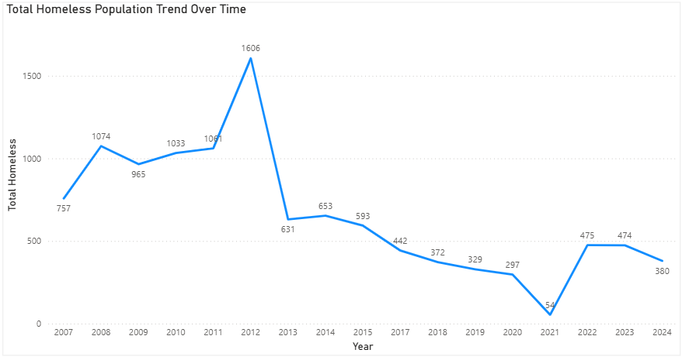
Figure 1: Homeless Population Trend in Cumberland County (2007-2024)
As shown in Figure 1, the total homeless population in Cumberland County exhibits significant variation over time, with a peak occurring around 2012 followed by a steady decline through 2021 and a subsequent increase in recent years. From a customer analytics perspective, this trend reflects fluctuations in overall customer demand for housing services. The sharp decline after 2012 may indicate improvements in service delivery or external economic factors, while the increase after 2021 suggests renewed pressure on the system and rising demand for homelessness services.
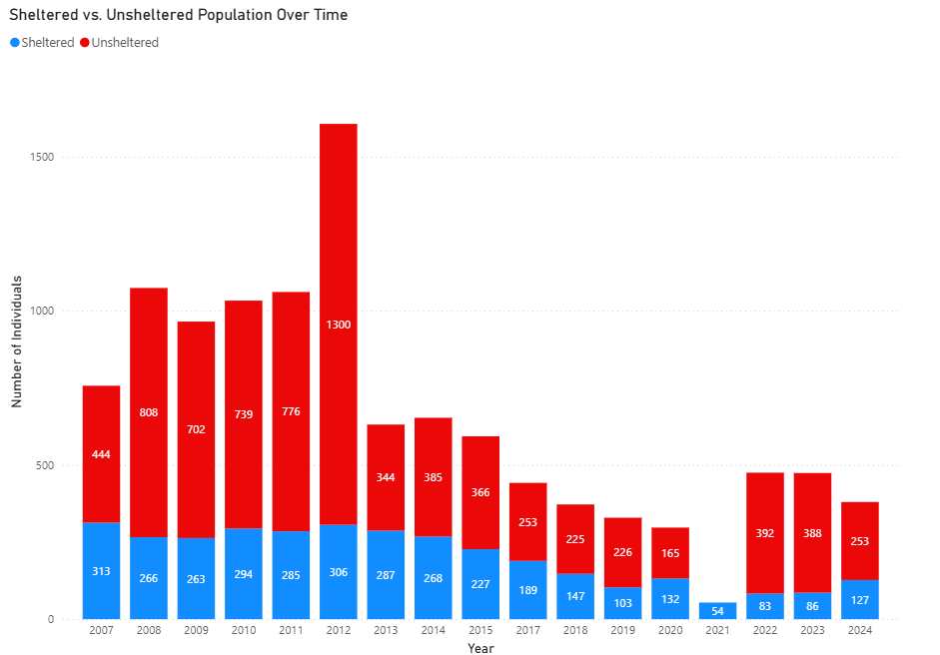
Figure 2: Sheltered vs. Unsheltered Population in Cumberland County (2007-2024)
Figure 2 highlights the distribution between sheltered and unsheltered populations over time. A consistent pattern emerges in which the unsheltered population exceeds the sheltered population in most years, indicating a gap in the system’s ability to transition into housing services.
In 2024, the unsheltered population of 253 individuals was approximately double the sheltered population of 127 individuals, meaning that nearly two out of every three individuals experiencing homelessness were not receiving shelter services. This reinforces the presence of a gap in the system’s ability to transition individuals into housing.
From a customer analytics perspective, this reflects a breakdown in the service funnel, where a large portion of individuals remain in the acquisition stage and are not successfully converted into housing placement. This suggests that system constraints, such as limited capacity, outreach effectiveness, or documentation barriers, are severely restricting the flow of individuals into stable housing.

Qualitative Portion
Qualitative insights further support these findings. During a site visit and interview with a local homelessness service provider, the director provided a tour of available services, including a food pantry, clothing resources, and educational support programs. While these services address immediate and supportive needs, the organization emphasized that securing shelter remains the most significant barrier for individuals experiencing homelessness
This observation aligns with the quantitative analysis, where a large portion of individuals remain unsheltered despite the presence of supportive services. Together, these findings suggest that while these supplemental services are readily available, limitations in housing capacity and placement remain the primary constraint within the system.

Forecast and Volatility Analysis
To evaluate future trends in homelessness, a three-year rolling average was applied to generate forecasts for 2025 through 2027. This method was selected due to its ability to smooth short-term fluctuations while preserving the underlying trends in the data, making it appropriate for strategic planning and resource allocation.
The forecast indicates that homelessness levels in Cumberland County are expected to remain elevated in the near term, with projected values of approximately 443 individuals in 2025, 432 in 2026, and 418 in 2027. While these projections suggest slight stabilization following recent increases, they do not indicate a return to the lower levels observed in prior years. From system perspective, this implies that demand for homelessness services will persist, with continuing, nonstop pressure on the allocation of resources.
To account for uncertainty in these projections, a volatility-adjusted approach was incorporated. Volatility was measured using the standard deviation of year-over-year percentage changes in homelessness counts. Initial estimates for Cumberland County were relatively high (approximately 25.9% overall), 19.7% for sheltered populations, and 37.5% for unsheltered populations, reflecting the inclusion of the extreme fluctuations across the observation period.
Upon further evaluation, data from 2021 and 2022 were identified as structural outliers due to the effects of the COVID-19 pandemic, which introduced atypical system conditions that do not reflect normal operating and counting behavior. Including these years in volatility calculations would overstate typical variability and reduce the practical usefulness of forecast ranges.
To address this, adjusted volatility estimates were applied to better represent normal system dynamics. An overall volatility range of approximately +/- 12% was used to construct upper and lower forecast bounds. These bounds provide a realistic range of potential outcomes while maintaining interpretability and avoiding distortion from atypical events.
The resulting forecast bands illustrate that, even under more favorable conditions, homelessness levels are expected to remain above the historical lows we viewed in the stacked bar chart, while less favorable conditions could result in further increases. The volatility forecast bands highlight the inherent variability in homelessness trends and emphasize the importance of proactive planning.
When considered along earlier findings, the forecast suggests that the existing imbalance between sheltered and unsheltered populations is highly unlikely to resolve without targeted intervention. As demand persists and variability remains present, the system may continue to face challenges in effectively transitioning individuals into housing, emphasizing the need for improved capacity alignment and outreach effectiveness.
Forecast results for North Carolina and Cumberland County (see Appendix A2 and Appendix B2) indicate differing levels of system stability, with the state showing narrower volatility bands compared to the county.

Implementation and Recommendations
The findings from this analysis highlight a structural imbalance within the homelessness service system in Cumberland County, particularly in the transition of individuals from unsheltered conditions into housing. To address this gap, targeted, data-driven strategies are recommended to improve outreach effectiveness, align system capacity with demand, and enhance data integration.

Improving outreach and engagement
The elevated and volatile unsheltered population indicates challenges with consistently engaging individuals experiencing homelessness. Targeted outreach strategies should use data to identify needed areas and prioritize resource deployment. Barriers to entry, such as documentation requirements, can improve engagement and increase the connections to services.

Increase Conversion Through Capacity Alignment
The imbalance between sheltered and unsheltered populations suggests that the system capacity is not fully aligned with demand. Expanding capacity and improving internal processes, such as case management and service coordination, can enhance the system’s ability to transition individuals into housing. These efforts directly address the conversion gap identified in the analysis.

Leveraging Forecasting for Resource Planning
Forecasting and volatility analysis provides a framework for proactive planning. By incorporating projected demand ranges, stakeholders can better anticipate fluctuations and allocate resources more effectively. This supports improved decision-making for managers in budgeting, staffing, and program development.

Enhancing Data Collection and Integration
The analysis identified limitations in data granularity and real-time tracking. Expanding the use of HMIS and improving data-sharing across organizations can enhance data quality and support more precise analysis. Tracking additional performance indicators, such as time to housing placement and return-to-homelessness rates, would strengthen the system evaluation.

Continuous Monitoring and KPI Development
Ongoing monitoring of key performance indicators is essential for sustained improvement. Metrics aligned with customer analytics, such as outreach effectiveness, housing placement rates, and retention, can help identify gaps and guide strategic adjustments. Regular evaluation ensures the system performance can and will remain with demand.

Project Evaluation

Project Outcomes
This project successfully applied customer analytics concepts to evaluate homelessness outreach and housing access within Cumberland County. Through the use of PIT data, key trends were identified, including fluctuations in total homelessness and a persistent imbalance between sheltered and unsheltered population. Even with fluctuation on the lower end, many remain unsheltered no matter what the total number is marked. The integration of forecasting and volatility analysis provides additional insight into future system conditions, highlighting continued demand and uncertainty. Overall, the project achieved its objective of developing a data-driven understanding of the current state of homelessness in Cumberland County, and what new KPIs and active measures must take place to narrow down the unsheltered percentage. This project established a foundation for further research that incorporates more granular and organization-level data that must be explored for better understanding of homelessness.

Contributions and Learning
This project contributed to a deeper understanding of how data analytics can be applied within a nonprofit and public service context. By framing individuals experiencing homelessness as customers in demand of a certain service, the analysis introduced a structured approach to evaluating outreach effectiveness, engagement, and housing conversion.
From a student perspective, the project strengthened skills in data cleaning, data forecasting, and application of customer analytic framework to reflect a real-world problem. It also highlighted the importance of understanding not only the numbers in quantitative reasoning, but also the qualitative insights that brings social relatability to a social challenge such as homelessness.

Team Performance
The team collaborated to complete the research, data analysis, and report development, with contributions across data collection, visualization, and interpretation. While coordination challenges were present, the project was successfully completed through individual accountability and shared commitment to producing a meaningful analysis.
The experience emphasized the importance of duty delegation, clear communication, time management, and ensuring everyone played a role in this group-based project.

Conclusion
This project applied customer analytics principles to evaluate homelessness outreach and housing data access within Cumberland County using publicly available PIT data. The analysis identified key trends, including fluctuations in total homelessness and a persistent imbalance between sheltered and unsheltered populations. While overall homelessness levels have declined over time, a significant portion of individuals remain unsheltered, indicating challenges in effectively transitioning individuals into housing services.
When comparing Cumberland County to the State of North Carolina, a clear pattern emerges. Although the county represents a smaller and declining share of the state’s total homeless population, it continues to account for a disproportionately large share of the unsheltered population while contributing a smaller share of the sheltered population. This imbalance suggests that the primary issue is not overall demand, but inefficiencies in converting individuals from outreach into housing placement.
The forecasting and volatility analysis further supports these findings, indicating that homelessness levels are expected to remain elevated in the near term, with continued variability in system performance. These results highlight the importance of proactive planning, improved capacity alignment, and more effective outreach strategies to address persistent gaps in service delivery.
This project primarily focused on analyzing publicly available, government-reported data to establish a reliable foundation for understanding homelessness trends. While this approach provides valuable high-level insights, it does not capture detailed, organization-leveled interactions or individual service journeys. As such, this work should be viewed as a foundational step toward more comprehensive analysis.
Future research should incorporate qualitative insights and data from nonprofits and service providers to better understand operational processes, customer behavior, and barriers to service access. Integrating these data sources would enable the development of more precise, marketing-oriented KPIs and support strategies that improve outreach effectiveness, increase housing conversion, and raise community awareness.
Ultimately, addressing homelessness not only requires the number of individuals experiencing homelessness, but also improves the system’s ability to have a consistent, reliable transitional program into stable housing. A data-driven, customer-focused approach provides a pathway for achieving more effective and sustainable outcomes.

Appendix

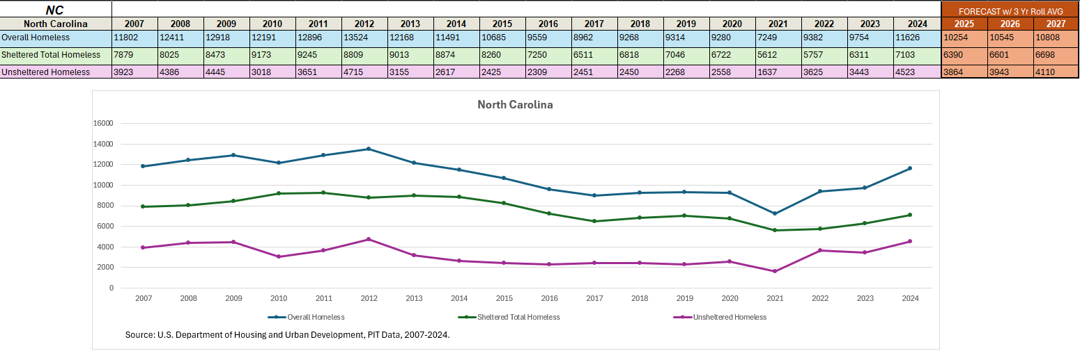
Appendix A: North Carolina Data and Analysis

Figure A1: North Carolina Homeless Population Trends (2007-2024)
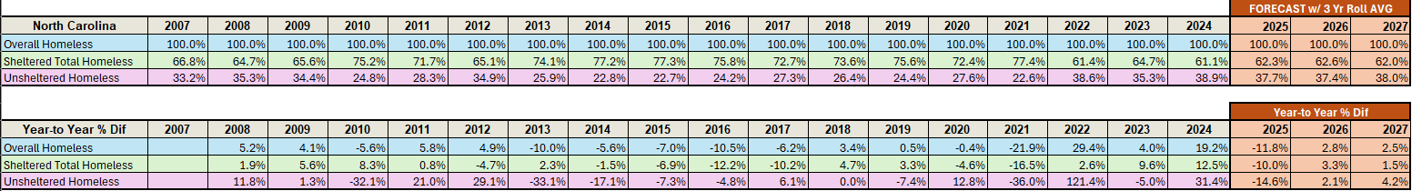Table A1: North Carolina Year-over-Year Percentage Changes (2007-2004)

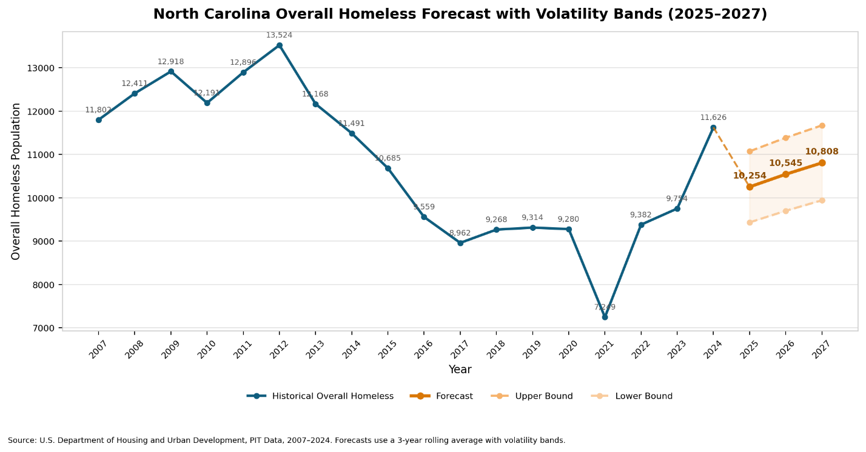

Figure A2: North Carolina Overall Homeless Forecast with Volatility Bands (2025-2027)
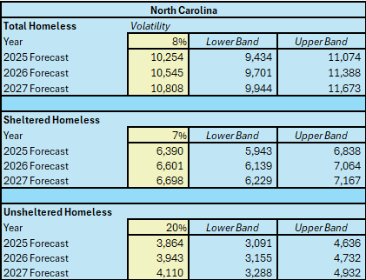

Table A2: North Carolina Forecast Volatility Bands by Category (2025-2027)

Appendix B: Cumberland County Data and Analysis
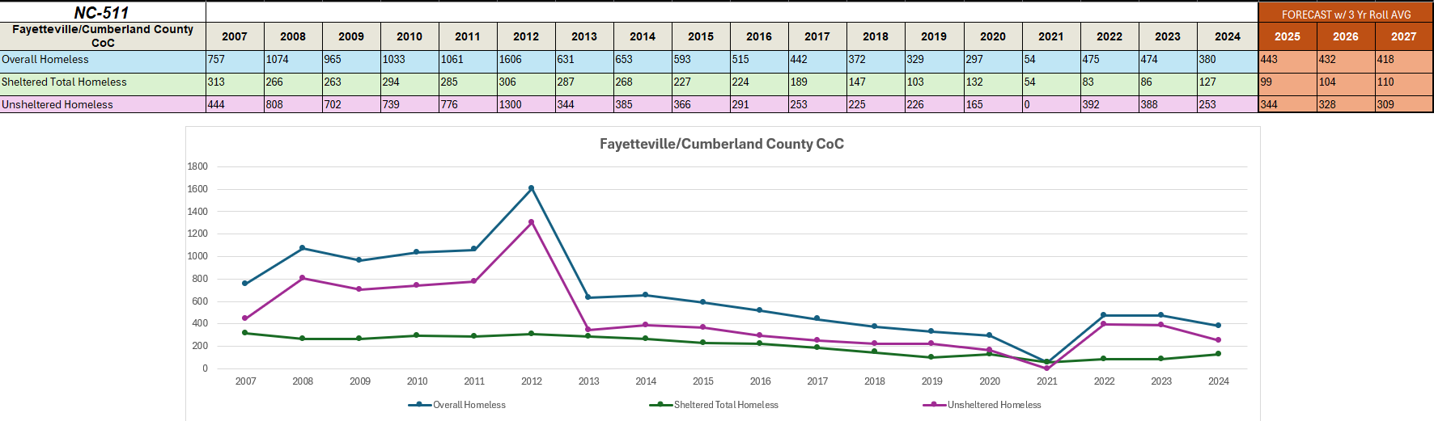

Figure B1: Cumberland County Homeless Population Trends (2007-2024)
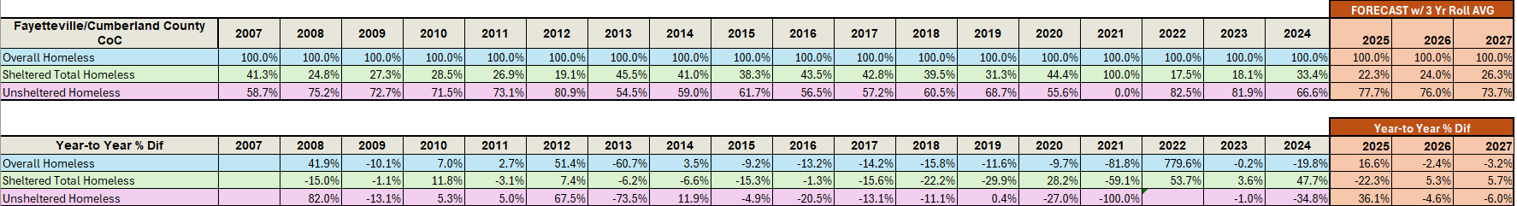

Table B1: Cumberland County Year-over-Year Percentage Changes (2007-2004)
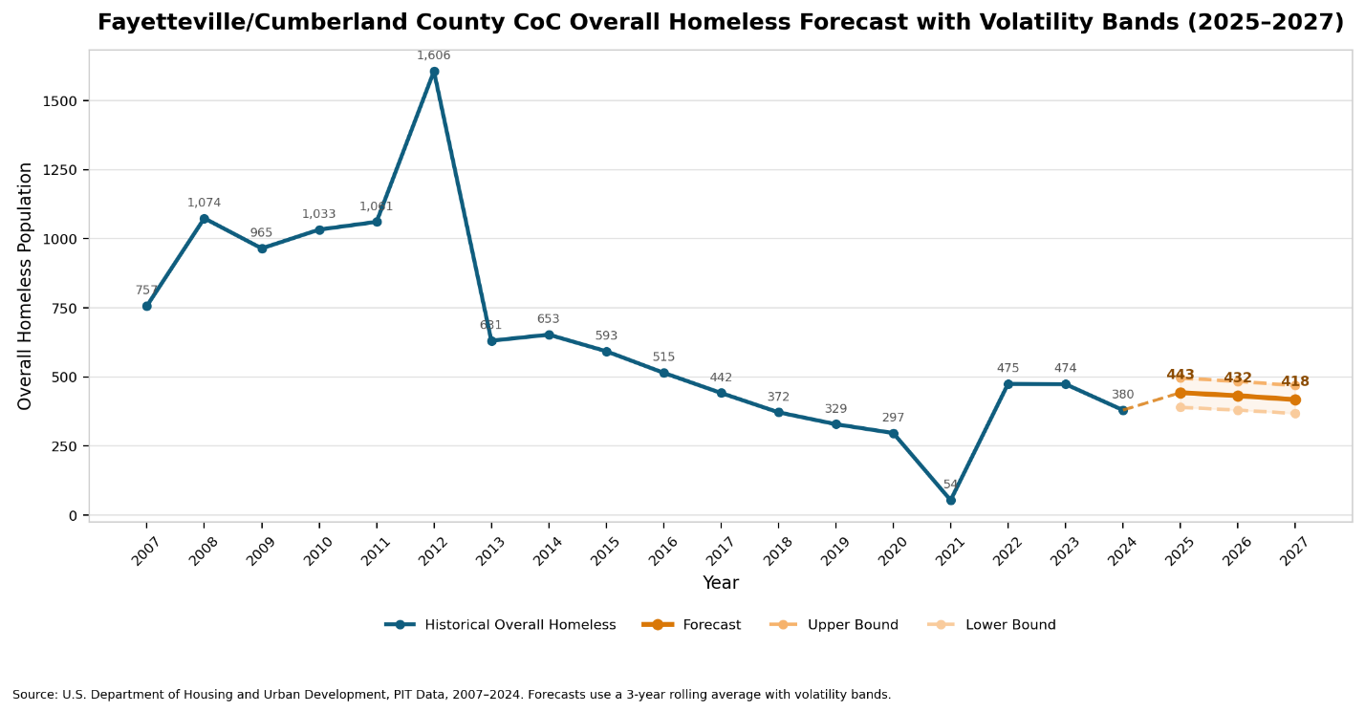

Figure B2: Cumberland County Overall Homeless Forecast with Volatility Bands (2025-2027)

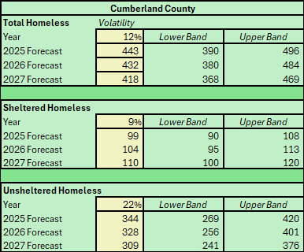

Table B2: Cumberland County Forecast Volatility Bands by Category (2025-2027)

References
Case Studies of Nonprofit Organizations Effectively Using ... (2025). https://socialtargeter.com/blogs/case-studies-of-nonprofit-organizations-effectively-using-data-analytics-to-drive-donations
Changing Perceptions on Homelessness Through ... (n.d.). Retrieved https://mediacause.com/our-work/case-study/changing-perceptions-mobilization-campaign/
Effective Messaging and the Solution to End Homelessness. (n.d.). Retrieved https://gomixte.com/blog/effective-messaging-solution-to-end-homelessness/
Evans, W., Phillips, D., & Ruffini, K. J. (2019). Reducing and Preventing Homelessness: A Review of the Evidence and Charting a Research Agenda. Randomized Social Experiments eJournal. https://www.nber.org/system/files/working_papers/w26232/w26232.pdf
Homelessness. (2025). https://isocialmarketing.org/homelessness/
Homelessness Toolkit to Support Local Businesses. (2025). https://fwhcc.org/homelessnesstoolkit/
Housing-Focused Street Outreach: Starting with Data to Inform Decision- ... (n.d.). Retrieved https://endhomelessness.org/webinars/housing-focused-street-outreach-starting-with-data-to-inform-decision-making/
How Can Social Marketing Help Reduce Homelessness in ... (2023). https://patimes.org/how-can-social-marketing-help-reduce-homelessness-in-the-united-states/
How to Leverage Data Analytics to Drive Non-Profit Growth. (2025). https://www.bradymartz.com/how-to-leverage-data-analytics-to-drive-non-profit-growth/
Innovative Marketing Strategies for Homeless Shelters. (2024). https://desygner.com/blog/industry/how-to-market-homeless-shelters-business
Kube, A., Das, S., & Fowler, P. J. (2019). Allocating Interventions Based on Predicted Outcomes: A Case Study on Homelessness Services. Proceedings of the AAAI Conference on Artificial Intelligence, 33(01), 622-629. https://doi.org/10.1609/aaai.v33i01.3301622
Marketing for Homeless Shelters and Housing Insecurity ... (n.d.). Retrieved https://nonprofit-nerd.com/marketing-homeless-shelters
Marshall CA, Boland L, Westover LA, Marcellus B, Weil S, Wickett S. Effectiveness of interventions targeting community integration among individuals with lived experiences of homelessness: A systematic review. Health Soc Care Community. 2020;28:1843–1862. https://doi.org/10.1111/hsc.13030
Navigating Homelessness and Housing Needs Data: Tailoring and ... (n.d.). Retrieved https://www.usich.gov/sites/default/files/document/Navigating-Homelessness-Housing-Needs-Data-2020-update.pdf
Nonprofit Analytics: Data Analysis Tools, Software & ... (2026). https://www.sopact.com/use-case/nonprofit-analytics
Social Media Marketing for Homeless Shelters - Waleed. (n.d.). Retrieved https://mwaleed.org/homeless-shelter-social-media-marketing/
Understanding the Role of Data Analytics in Homelessness Policy ... (2024). https://www.bitfocus.com/blog/role-of-data-in-homeless-policy-evaluation
U.S. Department of Housing and Urban Development. (2025). CoC program HMIS manual: A guide for HMIS end users and HMIS leads/system administrators (FY 2026 data standards). https://www.hud.gov
Using OOH to Help the Homeless. (2019). https://oaaa.org/blog-posts/using-ooh-to-help-the-homeless/
White, H., Saran, A., Fowler, B., Portes, A., Fitzpatrick, S., & Teixeira, L. (2019). PROTOCOL: Studies of the effectiveness of interventions to improve the welfare of those affected by, and at risk of, homelessness in high‐income countries: An evidence and gap map. Campbell Systematic Reviews. https://journals.sagepub.com/doi/full/10.1002/cl2.1069
Why Data Analytics Is Within Reach For Nonprofits. (2026). https://www.mjcpa.com/why-data-analytics-is-within-reach-for-nonprofits/

